ESTADISTICA DE NIÑOS POR CDI
INICIAL | CDI | I1F | I1M | I2F | I2M | I3F | I3M | TOTAL
INICIAL | SANTA CATARINA | 2 | 0 | 7 | 5 | 8 | 11 | 33
INICIAL | VALLE VERDE | 0 | 0 | 2 | 0 | 8 | 1 | 11
INICIAL | VALLE DEL SOL | 0 | 0 | 0 | 0 | 3 | 2 | 5
INICIAL | LOS ANGELES | 0 | 0 | 3 | 3 | 2 | 3 | 11
INICIAL | TOTAL | 2 | 0 | 12 | 8 | 21 | 17 | 60

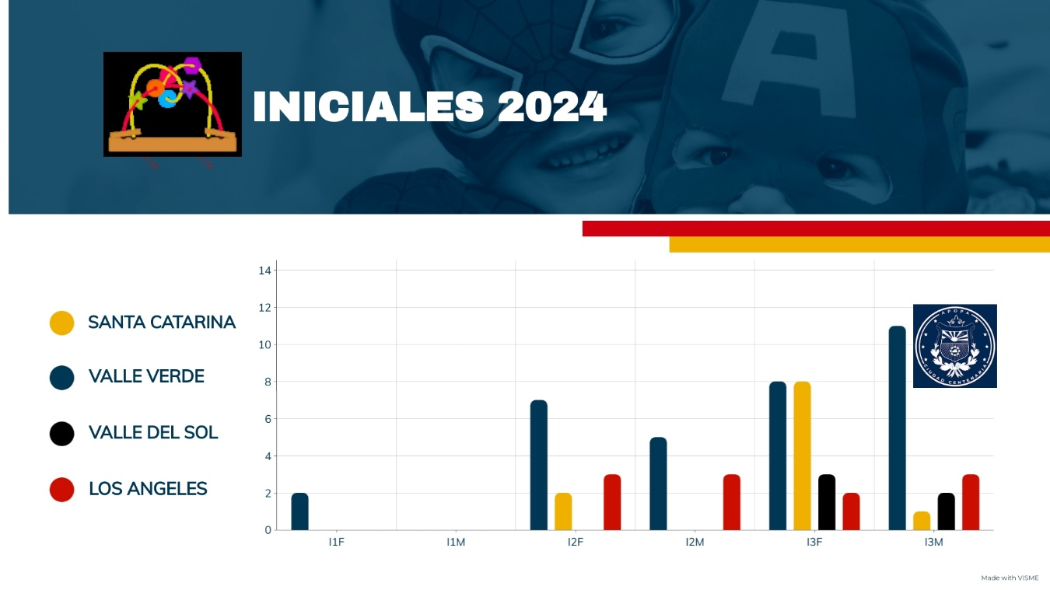
CENSO MATRICULA INICI
PARVULARIA | CDI | P4F | P4M | P5F | P5M | P6F | P6M | TOTAL
PARVULARIA | SANTA CATARINA | 12 | 10 | 6 | 13 | 5 | 4 | 50
PARVULARIA | VALLE VERDE | 7 | 12 | 6 | 6 | 0 | 0 | 31
PARVULARIA | VALLE DEL SOL | 13 | 13 | 6 | 7 | 8 | 10 | 57
PARVULARIA | LOS ANGELES | 5 | 6 | 8 | 8 | 10 | 9 | 46
PARVULARIA | TOTAL | 37 | 41 | 26 | 34 | 23 | 23 | 184
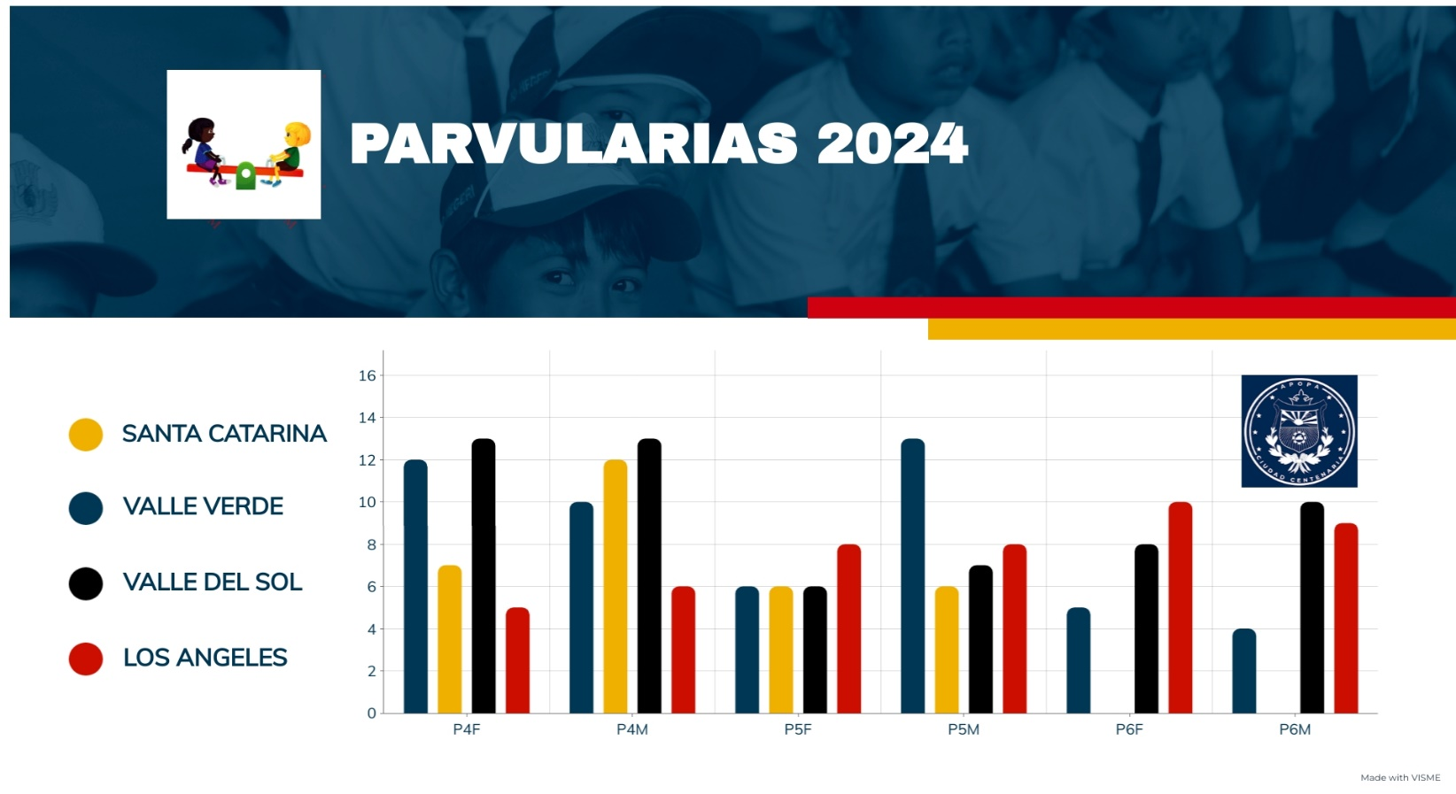
AL 2022
INICIAL
F-35 | M-25
PARVULARIA
F-86 | M-98
GENERAL
F-121 | M-123

TOTAL
244

